Game Design Document

# Background: The Game Design Document (GDD) serves as the overall design details document. The entire development team of writers, programmers, graphic artists, and others, will use the GDD to guide their work in the development process. A GDD is a “living” document in that it will be revised and updated by the team throughout the development process to reflect new ideas, alter plans, and resolve problems.

# Directions: Use the suggested section headings below to structure your GDD document. Headings that do not apply to your game can be deleted. Add additional headings as needed.

Title:

Medieval Fight

Game Type/Genre *(What sort of game and for what medium (console, mobile, pc)):*

Mainly PC…. Maybe mobile

*S*hort Description/Overview *(One paragraph or less)*

A Fighting game where you can choose your character and fight goblins, soldiers, and other monsters to save the rebel base.

Game Philosophy *(Why create this game?)*

To fill your free time and to have a challenge.

Audience *(Describe them and how the game meets their expectations)*

Younger aged people 8-18 will find it as a classic medieval game.

Innovation *(What is new, unique, or innovative about the game?)*

There will be a great challenge instead of it being so easy

Fun/Challenge

Kill enemies until reinforcements arrive.

Mood *(How do you feel when playing? What emotion(s) does the game evoke?)*

Excitement and nervousness

Comparison Games *(List similar games)*

Generic medieval game.

Scenario/Setting

Around village with surrounding forest and such

Characters/Players

Rebel fighter, enemies, goblins, monsters.

Plot *(Story structure or narrative. Include a graphic like a flowchart)*

The rebels have a small city that they need to defend but they can’t hold it without reinforcements from other cities around them. As all of their enemies close in on their city they fight to stay alive and wait for help.

Game Progression *(What changes during the game experience?)*

The difficulty of holding for reinforcements and the different spawn of enemies.

Game Play

Mechanics

User controls

WASD, Mouse, Num Pad

Graphics

Theme *(Style and perspective)*

Grid Layout

Levels *(Diagram the physical layout)*

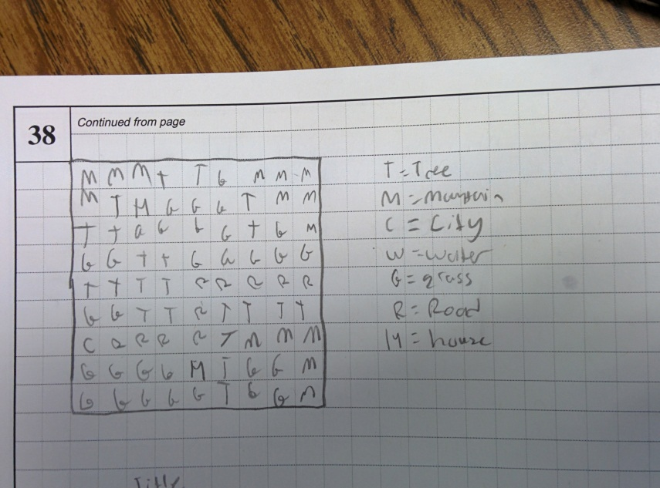

Screens *(Describe or sketch the title, information, cut scenes, etc.)*

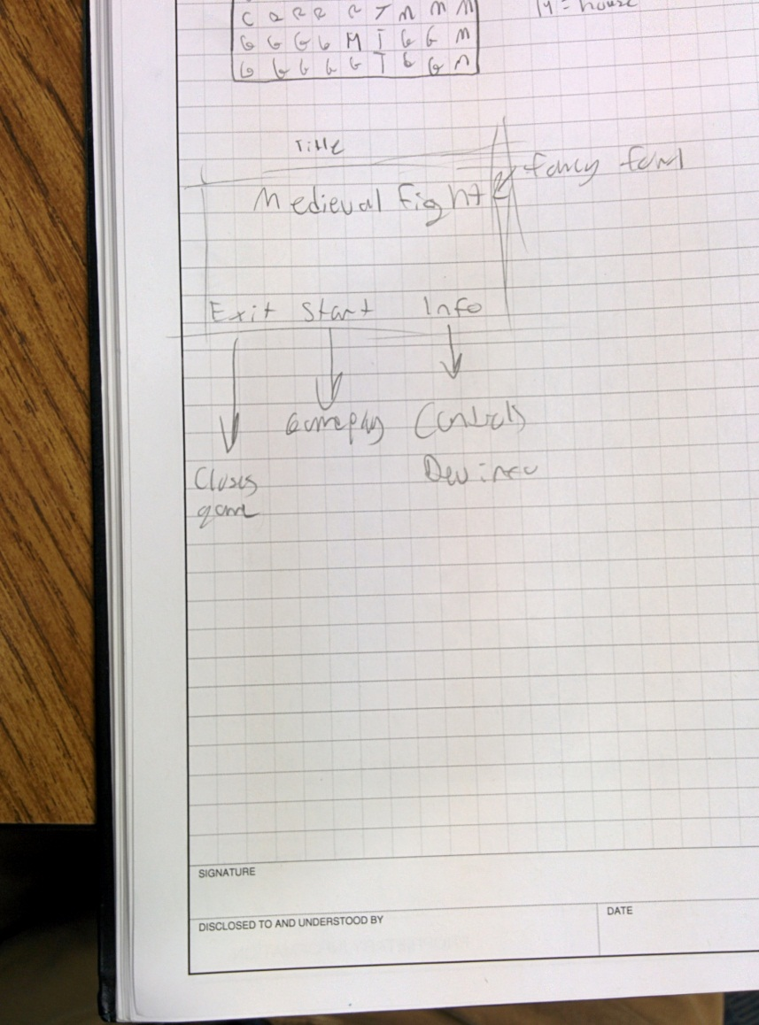

User Interface *(Diagram and write a short description)*

Square with small menu button

Audio *(Describe the background music, sound effects, and when they are activated)*

BG music

Fighting sounds